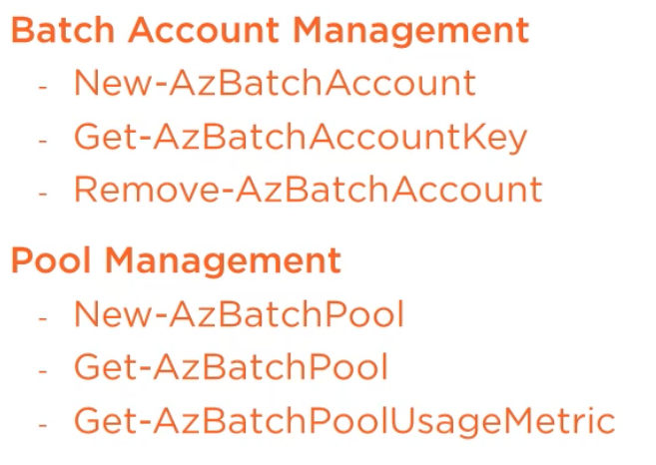

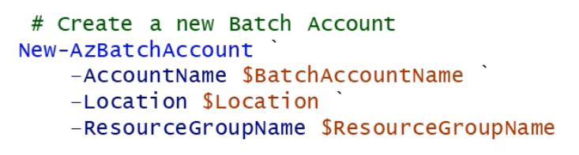

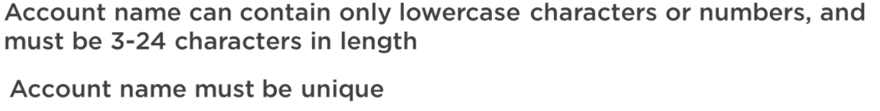

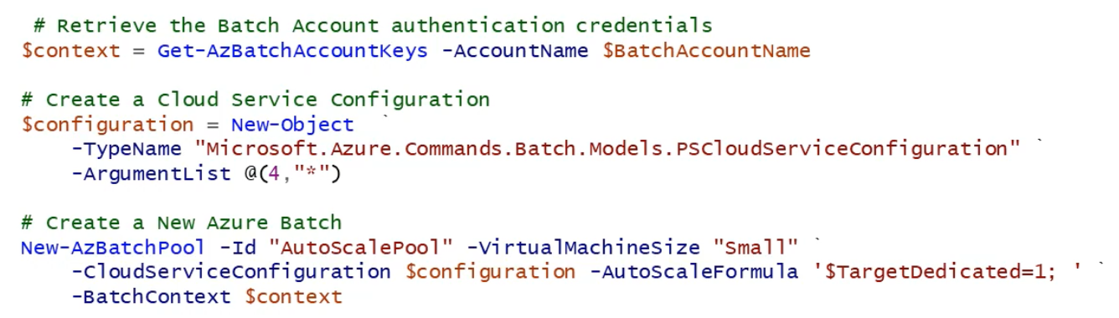

Id: AutoScalePool, RenderPool, LowPriorityRenderPool

Azure CLI:

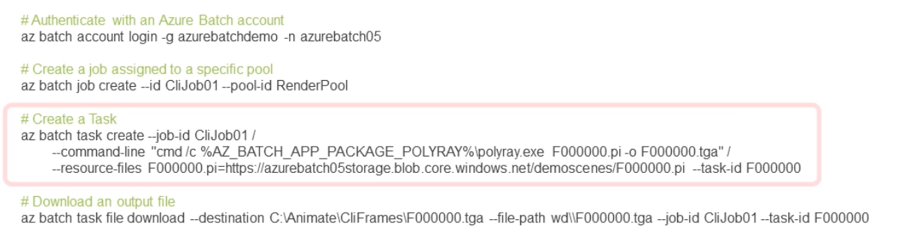

(-g as in group, -n as in name)

az batch account list